# Acceptance Test Plan

This is our acceptance test plan that we created by looking at what the user can see while using the application to fully test the both the front and back end of the program. We decided to order the tests by the flow of the application, not by the user story list to give a more user-friendly test plan that can be completed by simply by following the tests step-by-step. For the verification of the user stories, we used the iteration story list for the numbering as this is a more concrete list of what we had accomplished during the production of this application instead of giving the broad overview of all of what we could have done. So like I said before, follow these tests in order and you should have no difficulties while understanding what any of these tests are asking (even though the tests could be run in any order).

The following user stories were not included in the ATP. Reasons for their exclusion are as follows:

Removed from the Application

1, 8, 24, 29, 30, 57, 58, 106  
  
Never in the Application or Not Testable

66, 67, 71, 72, 73, 101, 109, 110, 111, 112, 113, 115, 116, 117, 118, 119, 120, 121, 122, 123, 125, 126, 127, 128, and 129

**Test 1: The app starts up correctly.**

Verifies user story: 2,15,16,45,46,47,48,75,79

Check to see phone is on. To do so, turn on the screen by pressing one of the side keys. Open up the phone by sliding the lock to the right (put in password if needed, if not known, ask the phone's owner). Then, open the apps menu by pressing the button on the bottom of the screen. Find and open Cause & Effect.

Process

Press the logo from the apps menu, see if it starts up.

Results

Able to start up (yes/no): ______

Comments: ________________________________________________________________________

________________________________________________________________________

[Passed/Failed]

____________

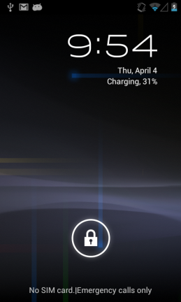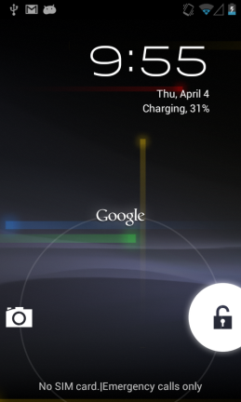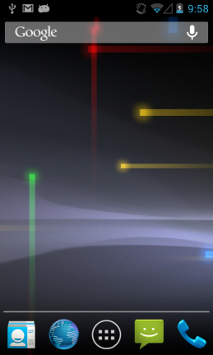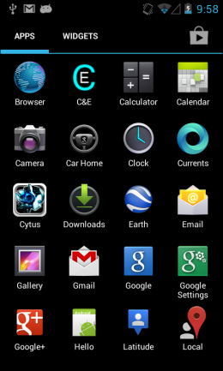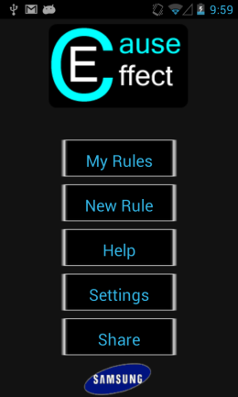

Lock Screen Unlocking Screen Home Screen All Apps Menu App Home Screen

**Test 2: Able to view all rules.**

Verifies user story: 4,17,18,19,20,21,22,65,77,104,105

Test by asking the user to tap My Rules from the home page.

Process

Press the My Rules button from home page button. Verify that all current rules show up (if there are no rules, the New Rule option on the Main Menu can be used to populate this screen, see Test 54).

Results

Able to view rules (yes/no):______

Comments:

________________________________________________________________________

________________________________________________________________________

[Passed/Failed]

____________

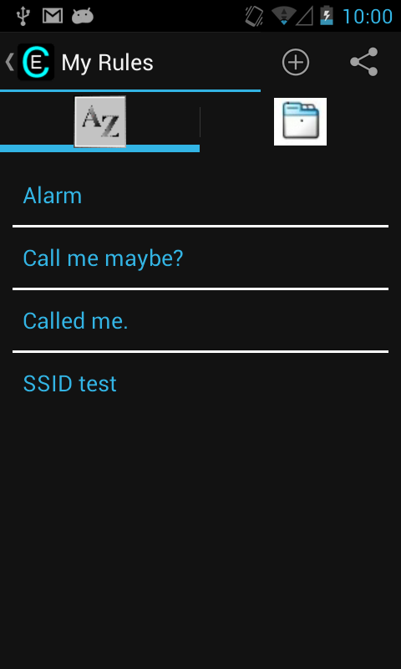

My Rules screen

**Test 3: Able to view details of a rule.**

Verifies user story: 5,28,80,81,85,102

Test by viewing the details of a rule.

Process

After following Test 2, tap on one of the rules (If there are no rules, go to the New Rule page from the main menu). Verify that the name is correct at the top, and that the rule’s causes and effects appear. If there are multiple causes, an AND or OR should be between them.

Results

Able to bring up details of rule (yes/no):______

Rule’s name appears and is correct (yes/no):______

“+” appears at bottom of both causes and effects (yes/no):______

(Possible) AND or OR shows up between multiple causes (yes/no):______

Comments:

________________________________________________________________________

________________________________________________________________________

[Passed/Failed]

____________

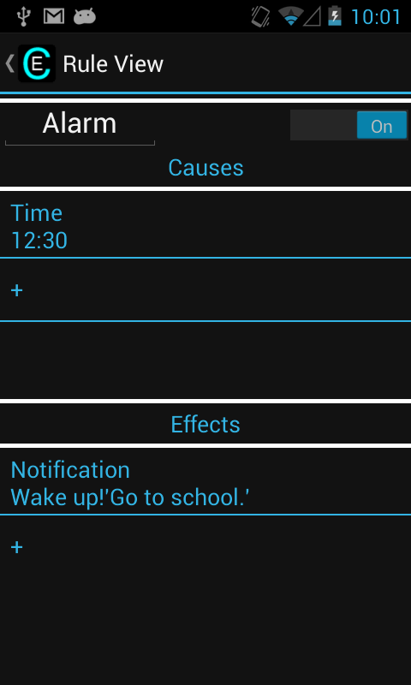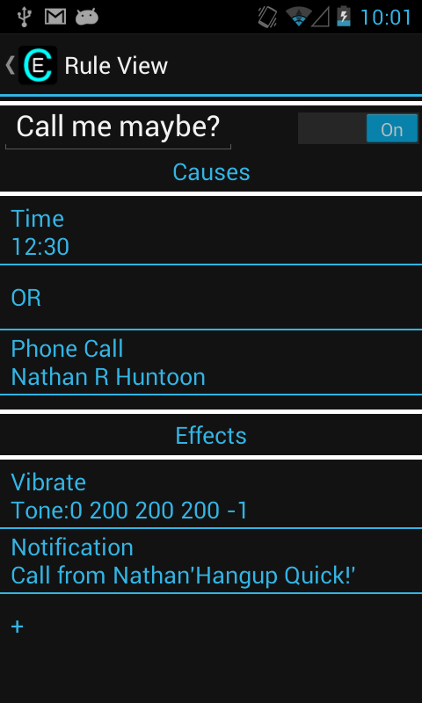

Edit Rule page Edit Rule page with OR

**Test 4: Arrive map location (GPS off).**

Verifies user story: 6,49,50,56,78,93,94

Test by having the user try to add the Cause: Arrival at a Destination, and view the first screen.

Process

Before doing this test, make sure the GPS is off (in your phone settings). At the top of your screen, there is a status bar. Touch and drag this bar down to see the entire status screen. At the top of the status screen, there is a settings icon (which is also located in the Apps Menu). Tap the settings icon to view your settings, and then scroll down and tap "Location Access." Turn off the GPS (location services) but leave the Wi-Fi and mobile networks on. After getting past Test 3, tap the “+” below the causes list to create a new cause. Tap “Arriving at a Location”. The Google maps should show up with the last known location. If you can't get your location, move to a different location with better signal strength. If this still doesn't work, restart your Wi-Fi and mobile networks, and try again.

Results

“Arriving at a Location” is a cause listed (yes/no):______

Last location known shows up on the screen (yes/no):______

Comments:

________________________________________________________________________

________________________________________________________________________

[Passed/Failed]

____________

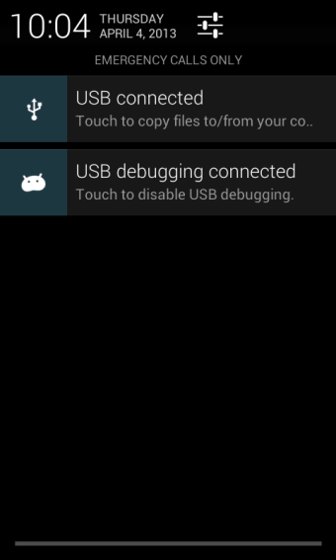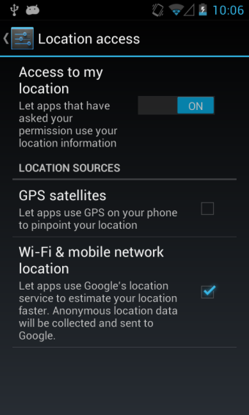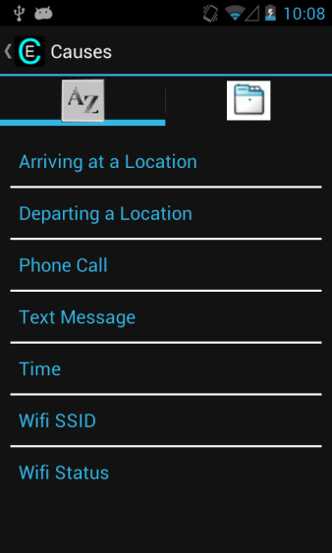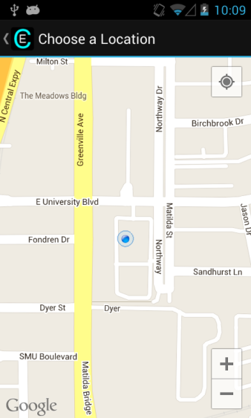

Pull-down screen Location menu Causes menu Google maps

**Test 5: Pan the Google map.**

Verifies user story: 93

Test by having the user try to pan the map pulled up by Test 4.

Process

As with most touch screens, attempt tap and drag the screen to pan the view of the Google map that is pulled up from Test 4.

Results

Able to pan map (yes/no):______

Comments:

________________________________________________________________________

________________________________________________________________________

[Passed/Failed]

____________

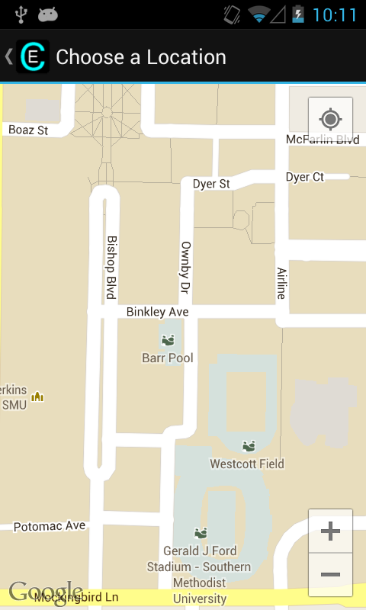

Google maps paned over to SMU

**Test 6: Zoom in on the Google map.**

Verifies user story: 93

Test by having the user try to zoom in all the way on the map pulled up by Test 4.

Process

As with most touch screens, put your two fingers together (preferably the thumb and index finger) on the screen. While pressing on the screen, slowly separate the two fingers to zoom in on the view of the Google map that is pulled up from Test 4 until you can no longer. Verify that app does not crash while doing so.

Results

Able to zoom in on map (yes/no):______

Comments:

________________________________________________________________________

________________________________________________________________________

[Passed/Failed]

____________

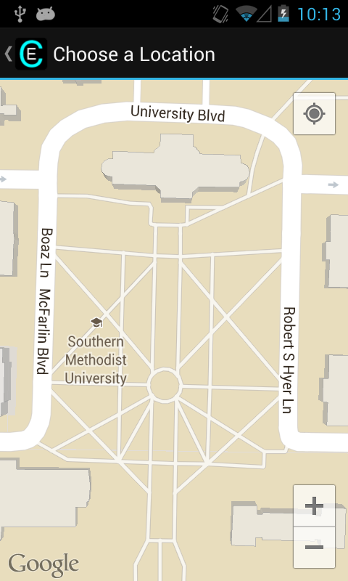

Zoomed-in view of SMU

**Test 7: Zoom out on the Google map.**

Verifies user story: 93

Test by having the user try to zoom out all the way on the map (pulled up by Test 4).

Process

As with most touch screens, put your two fingers apart (preferably the thumb and index finger) on the screen. While pressing on the screen, slowly close the two fingers to zoom out on the view of the Google map that is pulled up from Test 4 until you can no longer. Verify that app does not crash while doing so.

Results

Able to zoom out on map (yes/no):______

Comments:

________________________________________________________________________

________________________________________________________________________

[Passed/Failed]

____________

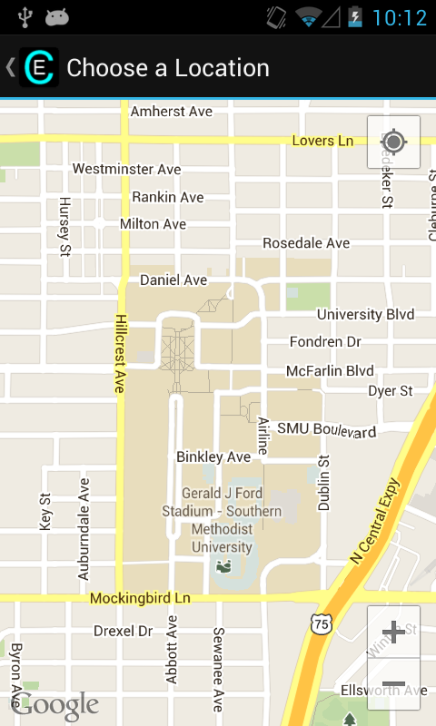

Zoomed-out Google maps

**Test 8: My location button (GPS off).**

Verifies user story: 93

Test by having the user try to use the My Location button on Google maps (top right of screen).

Process

Before doing this test, make sure the GPS is off (in your phone settings). Test 4 has an explanation on how to turn off your GPS. Press the My Location button on the top right of the screen. The screen should show a circle around your current location while also panning to your location.

Results

Circle shows up around a blue dot that includes your current location (yes/no):______

Dot shows up in the middle of the screen (yes/no):______

Comments:

________________________________________________________________________

________________________________________________________________________

[Passed/Failed]

____________

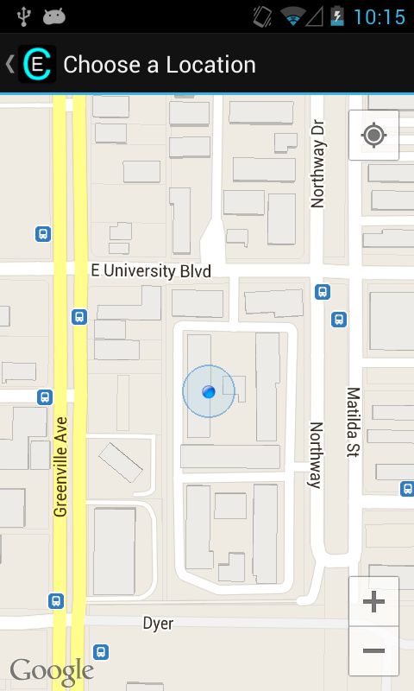

My Location screen (no GPS)

**Test 9: Arrive map location (GPS on).**

Verifies user story: 93,94

Test by having the user try to add the Cause: Arrival at a Destination and view the map screen.

Process

Before doing this test, make sure the GPS is on (in your phone settings). See Test 4 for details on how to get to the GPS in the Settings. After getting past Test 3, tap the “+” below the causes list to create a new cause. Tap “Arriving at a Location”. The Google maps should show up with the last known location. This will be a lot more accurate than with the GPS off. If you can't get GPS signal, move to a different location that can receive GPS signal (outside, clear skies).

Results

Last location known shows up on the screen (yes/no):______

Comments:

________________________________________________________________________

________________________________________________________________________

[Passed/Failed]

____________

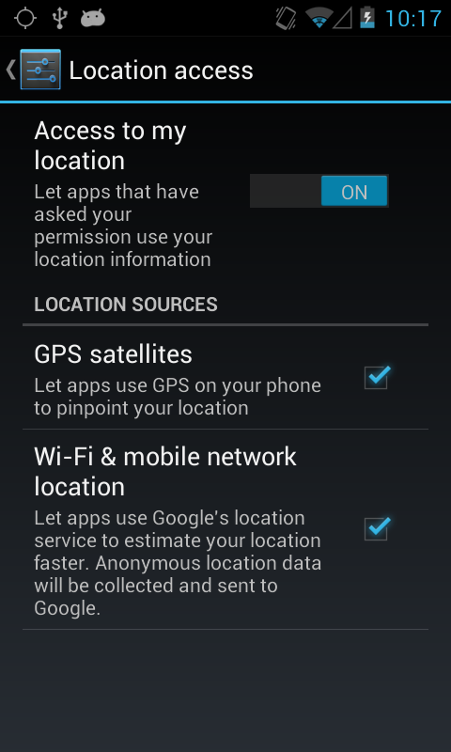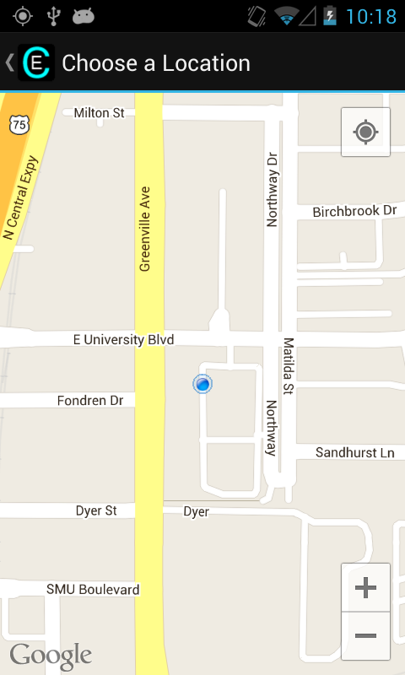

Turning GPS on Shown Location (GPS on)

**Test 10: My location button (GPS on).**

Verifies user story: 93

Test by having the user try to use the My Location button on Google maps (top right of screen).

Process

Before doing this test, make sure the GPS is on (in your phone settings). Press the My Location button in the top right of the screen. The screen should show a blue dot (or arrow) indicating your current location while also panning to your location (if you are zoomed in a small circle will appear).

Results

Blue dot shows your current location (yes/no):______

Dot shows up in the middle of the screen (yes/no):______

Comments:

________________________________________________________________________

________________________________________________________________________

[Passed/Failed]

____________

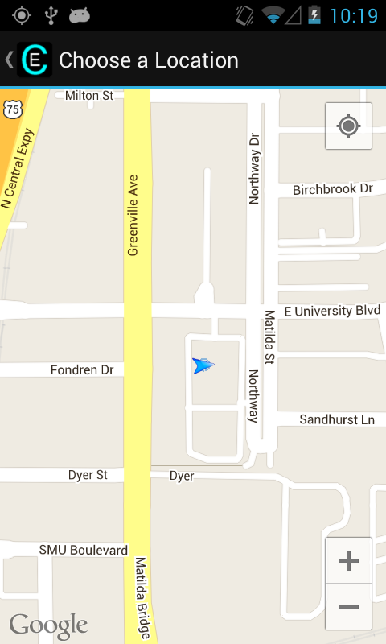

My Location (GPS on)

**Test 11: Tap to add pin to Google custom map.**

Verifies user story: 93

Test by having the user tap the screen on the Google map to add a pin.

Process

While inside of Arriving at a Location, tap on the screen to add a pin. A dialog should appear that asks for a name for the location. Leave the name blank and tap cancel. Some phones may not have a cancel button, instead use the back button. The screen should clear, and no pins should be visible anymore.

Results

Pin appears on screen after tapping (yes/no):______

Pin disappears on screen after tapping Cancel (yes/no):______

Comments:

________________________________________________________________________

________________________________________________________________________

[Passed/Failed]

____________

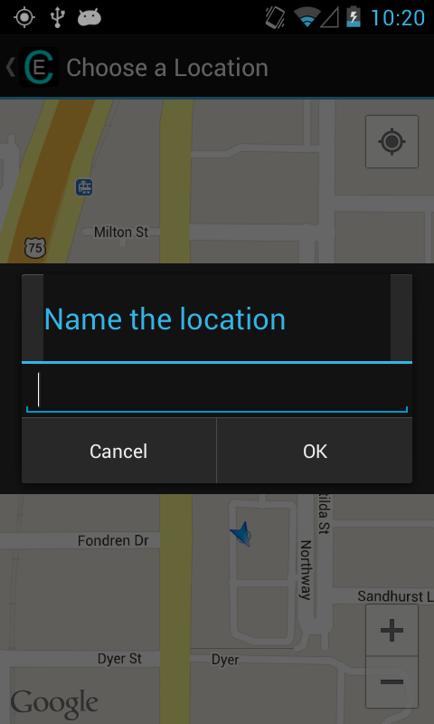

Adding a pin

**Test 12: Tap to add multiple pins to Google custom map.**

Verifies user story: 93

Test by having the user tap the screen on the Google map to add a pin.

Process

While inside of Arriving at Location, tap on the screen to add a pin. A dialog should appear that asks for a name of the location. Leave the name blank and tap OK. The pin should still be visible. A blue overlay will appear to show the location that the rule is in effect. Repeat this process a couple times to keep adding more pins. Multiple pins should be visible. If you were to approve of this choice, the most recent pin would be used for the cause. Now add a new pin and instead of tapping OK, tap cancel. Some phones may not have a cancel button, instead use the back button. All pins should now be gone.

Results

Pin appears on screen after tapping (yes/no):______

Multiple pins appear after creating multiple (yes/no):______

All pins disappear on screen after tapping Cancel (yes/no):______

Comments:

________________________________________________________________________

________________________________________________________________________

[Passed/Failed]

____________

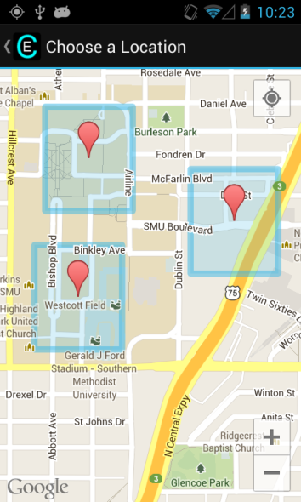

Multiple pins shown on map

**Test 13: Tap to add pin to Google custom map (blank name).**

Verifies user story: 31,32,33,34,35,36,37,38,39,40,41,42,43,44,52,53,54,55, 68,69,82,93,99,108

Test by having the user tap the screen on the Google map to add a pin.

**Note:** This is the first time the back-end is used, so all relevant backend user stories are listed only on this test.

Process

While inside of Arriving at Location, tap on the screen to add a pin. A dialog should appear that asks for a name for the location. Leave the name blank and tap OK. Tap and hold inside of the square to accept the location. Verify that this rule now appears in the cause list. Verify that the rule works by arriving at this location specified.

Results

Pin appears on screen after tapping (yes/no):______

Able to add pin with blank name (yes/no):______

Holding accepts the rule and stops the editing of the cause (yes/no):______

New cause appears at the bottom of the cause list (yes/no):______

Cause is triggered when arriving at the location (yes/no):______

Comments:

________________________________________________________________________

________________________________________________________________________

[Passed/Failed]

____________

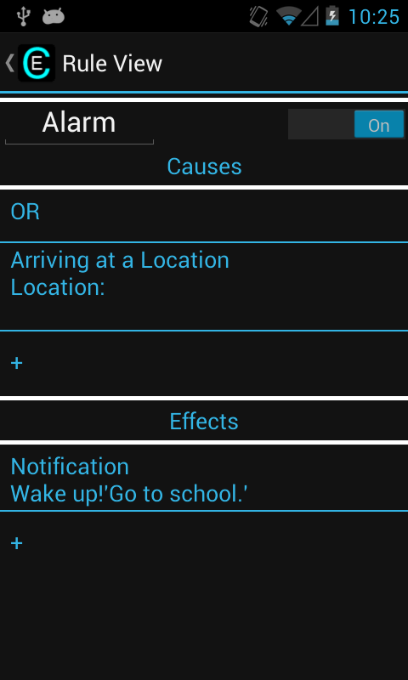

Rule with blank pin for Arriving

**Test 14: Tap to add pin to Google custom map (actual name).**

Verifies user story: 93

Test by having the user tap the screen on the Google map to add a pin.

Process

While inside of Arriving at Location, tap on the screen to add a pin. A dialog should appear that asks for a name of the location. Fill in the name and tap OK. The screen should show the pin. Tap and hold inside of the square to accept the location. Verify that this rule now appears in the cause list with the name visible after “Location: “ in the cause. Verify that the cause works by arriving at the specified location.

Results

Pin appears on screen after tapping (yes/no):______

Able to add pin with blank name (yes/no):______

Holding accepts the rule and stops the editing of the cause (yes/no):______

New cause appears at the bottom of the cause list with name (yes/no):______

New cause triggers the rule effects (yes/no):______

Comments:

________________________________________________________________________

________________________________________________________________________

[Passed/Failed]

____________

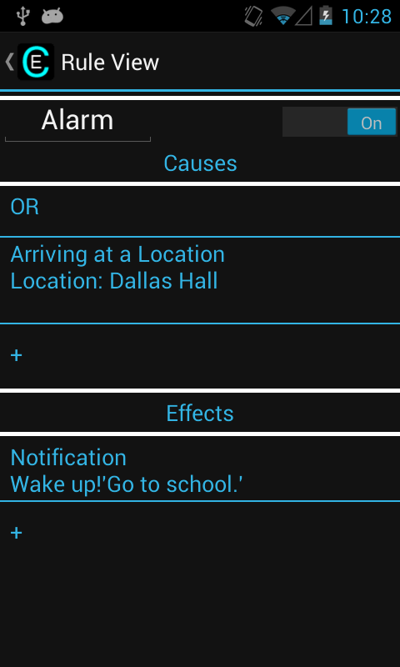

Rule with filled Arrive cause

**Test 15: Tap to add pin to Google custom map (blank name).**

Verifies user story: 93

Test by having the user try to add the Cause: Departing a Location, and follow the steps to create the cause.

Process

After getting past Test 3, tap the “+” below the causes list to create a new cause. Tap “Departing a Location”. The Google maps should show up with the last known location. Tap on the screen to add a pin. Leave the name blank and tap OK. Tap and hold inside the square to finalize the location. The new cause should show up at the bottom of the cause list. Finally, verify that leaving the designated location triggers the rule effects.

Results

“Departing at a Location” is a cause listed (yes/no):______

Last location known shows up on the screen (yes/no):______

Able to add blank pin (yes/no):______

Holding accepts the rule and stops the editing of the cause (yes/no):______

New cause appears at the bottom of the cause list (yes/no):______

New cause triggers the rule effects (yes/no):______

Comments:

________________________________________________________________________

________________________________________________________________________

[Passed/Failed]

____________

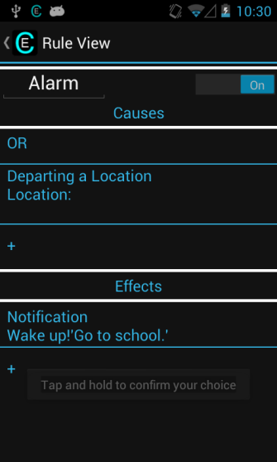

Rule with blank Departing cause

**Test 16: Tap to add pin to Google custom map (actual name).**

Verifies user story: 93

Test by having the user try to add the Cause: Departing a Location, and follow the steps to create the cause.

Process

While inside of departing a location, tap on the screen to add a pin. Fill in the name and tap OK. Tap and hold inside the square to finalize the location. The new cause should show up at the bottom of the cause list. Verify that this rule now appears in the cause list with the name visible after “Location: “ in the cause. Finally, verify that leaving the designated location triggers the rule effects.

Results

Able to add actual name pin (yes/no):______

Holding accepts the rule and stops the editing of the cause (yes/no):______

New cause appears at the bottom of the cause list with name (yes/no):______

New cause triggers the rule effects (yes/no):______

Comments:

________________________________________________________________________

________________________________________________________________________

[Passed/Failed]

____________

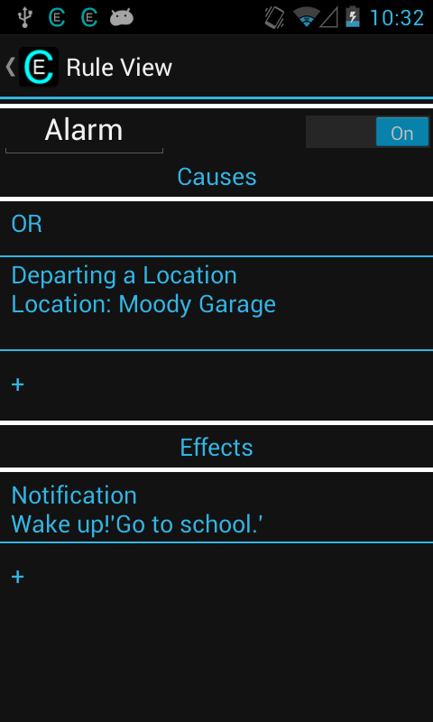

Rule with filled Departing cause

**Test 17: Adding Phone Call cause.**

Verifies user story: 51,59

Test by having the user try to add the cause of phone call.

Process

After getting past Test 3, tap the “+” below the causes list to create a new cause. Tap “Phone Call”. Your contact list should be displayed. Tap on one of the contacts (if you have no contacts, add one and restart the test). The new cause should now be displayed at the bottom of the list with the correct name. Verify that the rule works by having that contact call the phone.

Results

“Phone Call” is a cause listed (yes/no):______

Contact list displayed (yes/no):______

New cause added to list with correct contact name (yes/no):______

Rule effects triggered by new cause (yes/no):______

Comments:

________________________________________________________________________

________________________________________________________________________

[Passed/Failed]

____________

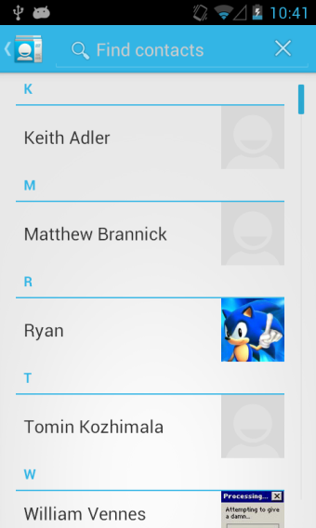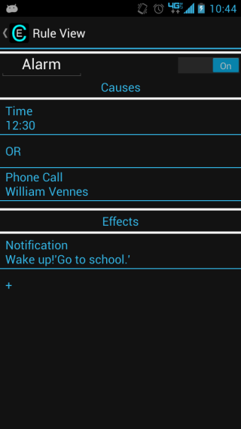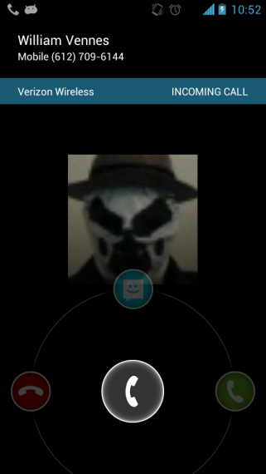

Contact List Added Phone Call cause Incoming Call

**Test 18: Adding Text message cause.**

Verifies user story: 60

Test by having the user try to add the cause of text message.

Process

After getting past Test 3, tap the “+” below the causes list to create a new cause. Tap “Text Message”. Your contact list should be displayed. Tap on one of the contacts (if you have no contacts, add one and restart test). The new cause should now be displayed at the bottom of the list with the correct name. Verify that the rule works by having that contact text the phone.

Results

“Text Message” is a cause listed (yes/no):______

Contact list displayed (yes/no):______

New cause added to list with correct contact name (yes/no):______

Rule effects triggered by new cause (yes/no):______

Comments:

________________________________________________________________________

________________________________________________________________________

[Passed/Failed]

____________

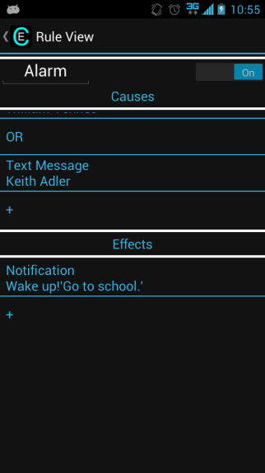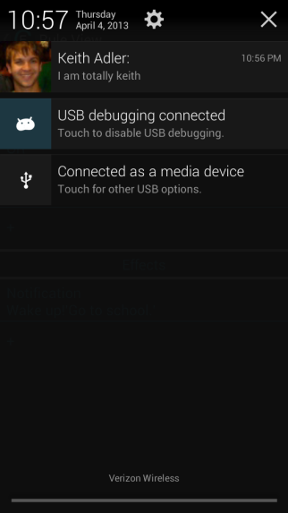

Added Text Message Cause Incoming Text Message

**Test 19: Adding Time cause.**

Verifies user story: 61

Test by having the user try to add the cause of time.

Process

After getting past Test 3, tap the “+” below the causes list to create a new cause. Tap “Time”. Input a time and tap OK. The new cause should now be displayed at the bottom of the list with the correct time. Verify that the rule works by waiting for that time.

Results

“Time” is a cause listed (yes/no):______

Time input dialog displayed (yes/no):______

New cause added to list with correct time (military time) (yes/no):______

Rule effects triggered by new cause (yes/no):______

Comments:

________________________________________________________________________

________________________________________________________________________

[Passed/Failed]

____________

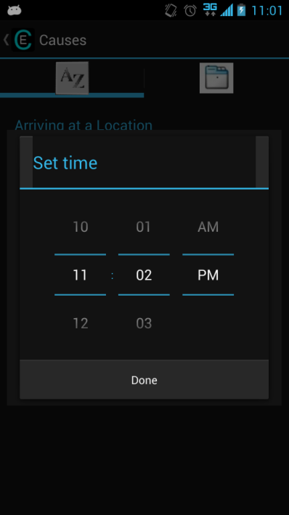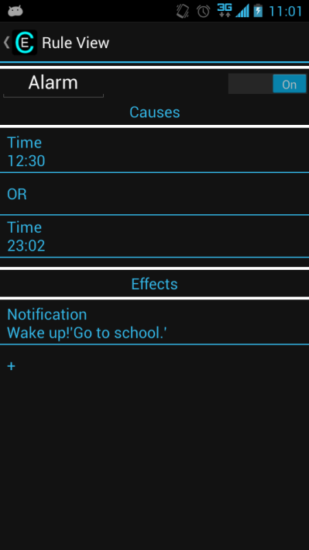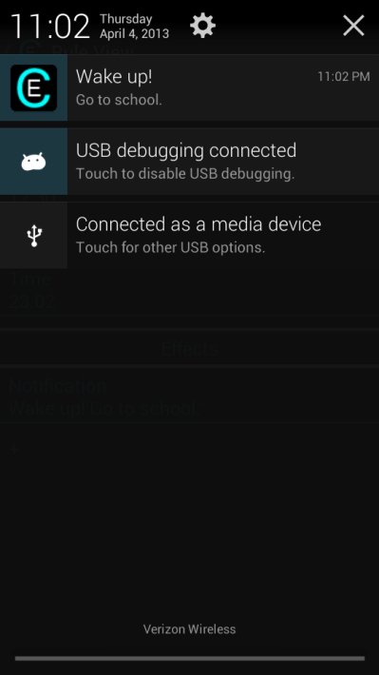

Adding Time Cause Rule with added Time Cause Notification from Rule

**Test 20: Adding Time cause (cancel).**

Verifies user story: 61

Test by having the user try to add the cause of time.

Process

After getting past Test 3, tap the “+” below the causes list to create a new cause. Tap “Time”. Input a time and tap cancel. No new cause should be added.

Results

Time input dialog displayed (yes/no):______

No new cause added (yes/no):______

Comments:

________________________________________________________________________

________________________________________________________________________

[Passed/Failed]

____________

**Test 21: Adding Wi-Fi SSID cause.**

Verifies user story: 96,107

Test by having the user try to add the cause of Wi-Fi SSID.

Process

After getting past Test 3, tap the “+” below the causes list to create a new cause. Tap “Wi-Fi SSID”. A create dialog should appear asking for text input. Input a name for the SSID (wireless network name) and tap Submit. Verify that the new cause appears at the bottom of the cause list, and that the rule effects are triggered by entering the range of the SSID.

Results

“Wi-Fi SSID” is a cause listed (yes/no):______

Create dialog appears (yes/no):______

Able to create new cause with correct SSID name (yes/no):______

Rule activates correctly (yes/no):______

Comments:

________________________________________________________________________

________________________________________________________________________

[Passed/Failed]

____________

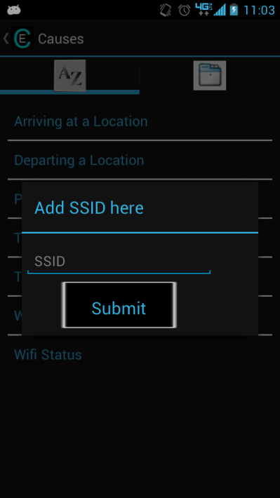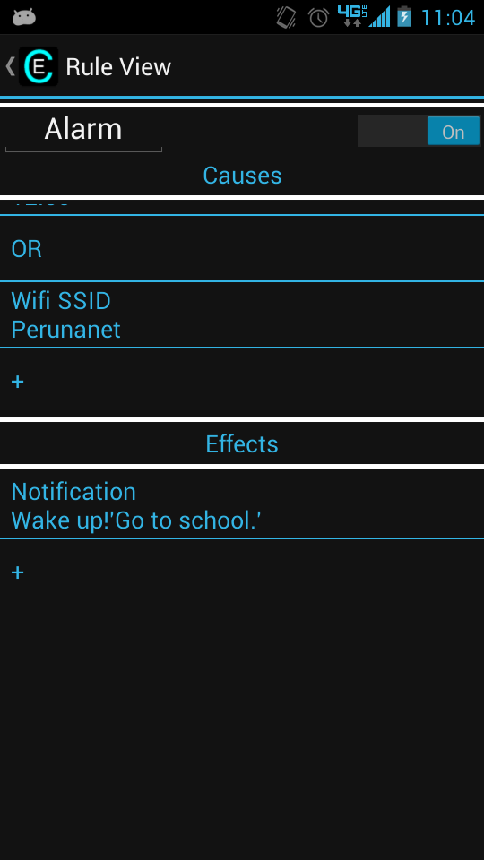

Adding an SSID Cause Rule with added SSID Cause

**Test 22: Adding Wi-Fi SSID cause (blank).**

Verifies user story: 96,107

Test by having the user try to add the cause of Wi-Fi SSID.

Process

After getting past Test 3, tap the “+” below the causes list to create a new cause. Tap “Wi-Fi SSID”. A create dialog should appear asking for text input. Leave the name blank and tap Submit. Verify that the new cause appears at the bottom of the cause list.

Results

“Wi-Fi SSID” is a cause listed (yes/no):______

Create dialog appears (yes/no):______

Able to create new cause with blank SSID name (yes/no):______

Comments:

________________________________________________________________________

________________________________________________________________________

[Passed/Failed]

____________

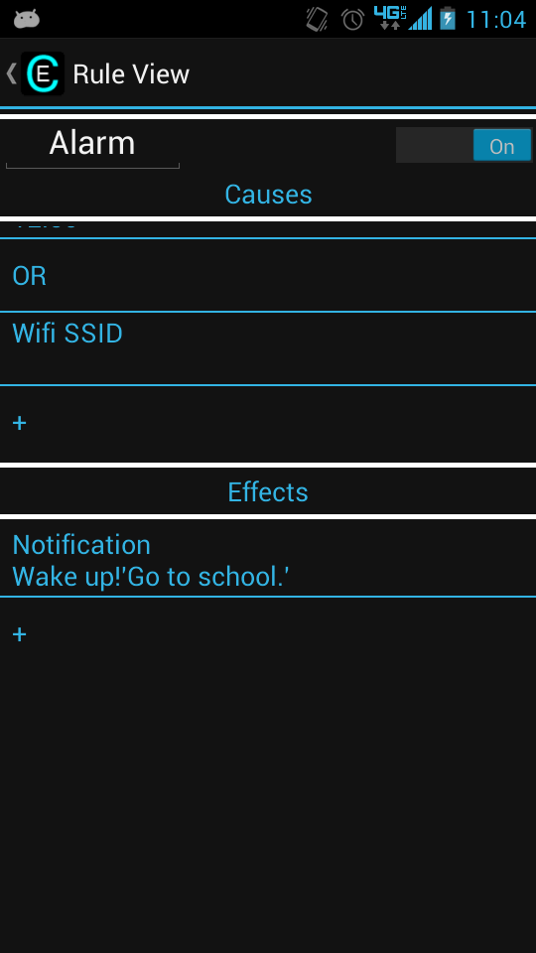

Rule with blank SSID

**Test 23: Adding Wi-Fi Status cause (on).**

Verifies user story: 96,107

Test by having the user try to add the cause of Wi-Fi Status.

Process

After getting past Test 3, tap the “+” below the causes list to create a new cause. Tap “Wi-Fi Status”. A create dialog should appear with a slider (default in off position). Slide the slider into the one position and tap Submit. Verify that the new cause appears at the bottom of the cause list, and that the rule effects are triggered by turning on the Wi-Fi.

Results

“Wi-Fi Status” is a cause listed (yes/no):______

Create dialog appears with slider (yes/no):______

Able to create new cause with correct status (yes/no):______

Rule activates correctly (yes/no):______

Comments:

________________________________________________________________________

________________________________________________________________________

[Passed/Failed]

____________

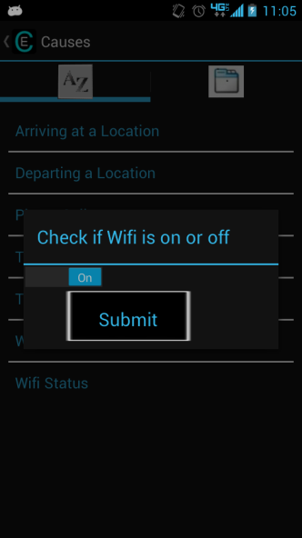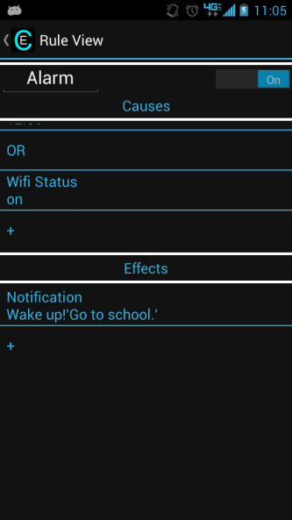

Added Wifi on Cause Rule with added Wifi cause (on)

**Test 24: Adding Wi-Fi Status cause (off).**

Verifies user story: 96,107

Test by having the user try to add the cause of Wi-Fi Status.

Process

After getting past Test 3, tap the “+” below the causes list to create a new cause. Tap “Wi-Fi Status”. A create dialog should appear with a slider (default in off position). Leave it in the off position and tap Submit. Verify that the new cause appears at the bottom of the cause list, and that the rule effects are triggered by turning off the Wi-Fi.

Results

Able to create new cause with correct status (yes/no):______

Rule activates correctly (yes/no):______

Comments:

________________________________________________________________________

________________________________________________________________________

[Passed/Failed]

____________

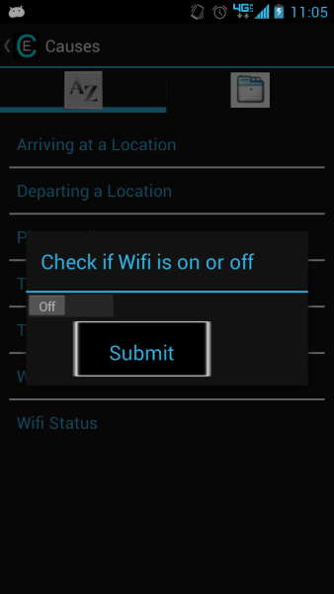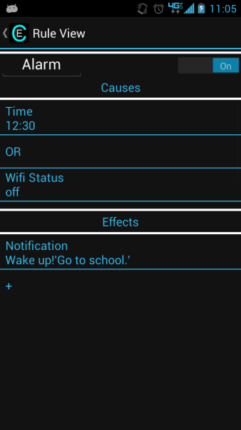

Adding Wifi Cause (off) Rule with added Wifi cause (off)

**Test 25: Adding Notification effect (blank).**

Verifies user story:7,62

Test by having the user try to add the effect of notification.

Process

After getting past Test 3, tap the “+” below the effects list to create a new effect. Tap “Notification”. A create dialog should appear waiting for input of text for Title and Subtext. Leave both blank and tap Submit. Verify that the new effect appears at the bottom of the effect list, and that the rule effect is triggered by activating the rule (making the causes true, whatever they may be).

Results

“Notification” is an effect listed (yes/no):______

Create dialog appears with empty text slots (yes/no):______

Able to create new effect with correct text (blank) (yes/no):______

Notification effect added to list (yes/no):______

Effect is displayed correctly (yes/no):______

Comments:

________________________________________________________________________

________________________________________________________________________

[Passed/Failed]

____________

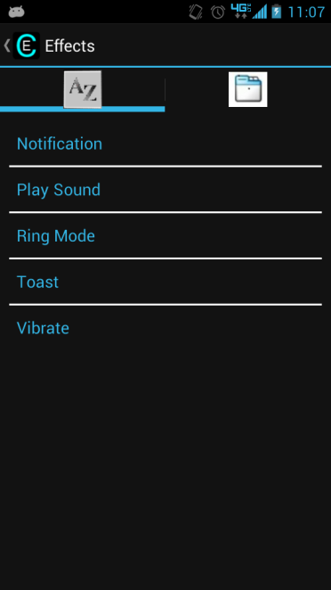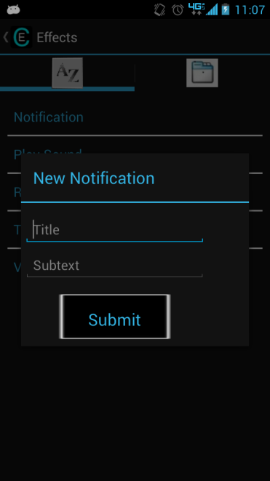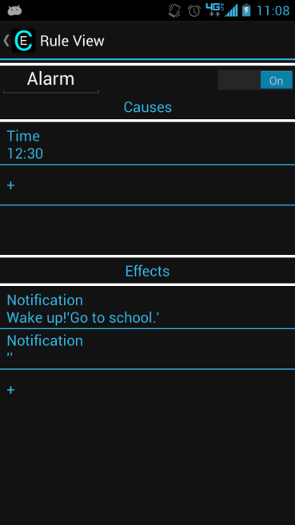

Effects Screen Adding new Notification effect Rule with new Notification effect

**Test 26: Adding Notification effect (Title only).**

Verifies user story: 62

Test by having the user try to add the effect of notification.

Process

While inside creating a notification (Test 25), fill in the Title box but leave Subtext blank and tap Submit. Verify that the new effect appears at the bottom of the effect list, and that the rule effect is triggered by activating the rule (making the causes true, whatever they may be).

Results

Able to create new effect with correct text (yes/no):______

Notification effect added to list (yes/no):______

Effect is displayed correctly (yes/no):______

Comments:

________________________________________________________________________

________________________________________________________________________

[Passed/Failed]

____________

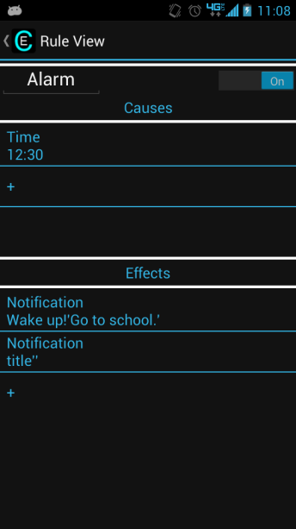

Rule with Notification with only Title

**Test 27: Adding Notification effect (Message only).**

Verifies user story: 62

Test by having the user try to add the effect of notification.

Process

While inside creating a notification (Test 25), fill in only the Subtext box, and tap Submit. Verify that the new effect appears at the bottom of the effect list, and that the rule effect is triggered by activating the rule (making the causes true, whatever they may be).

Results

Able to create new effect with correct text (yes/no):______

Notification effect added to list (yes/no):______

Effect is displayed correctly (yes/no):______

Comments:

________________________________________________________________________

________________________________________________________________________

[Passed/Failed]

____________

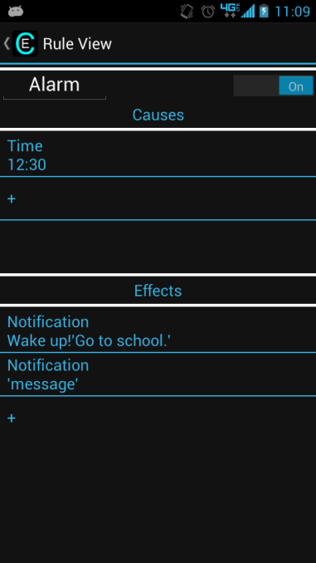

Rule with Notification Effect with Message only

**Test 28: Adding Notification effect (Full notification).**

Verifies user story: 62

Test by having the user try to add the effect of notification.

Process

While inside creating a notification (Test 25), fill in the Subtext box and the Title box, then tap Submit. Verify that the new effect appears at the bottom of the effect list, and that the rule effect is triggered by activating the rule (making the causes true, whatever they may be).

Results

Able to create new effect with correct text (yes/no):______

Notification effect added to list (yes/no):______

Effect is displayed correctly (yes/no):______

Comments:

________________________________________________________________________

________________________________________________________________________

[Passed/Failed]

____________

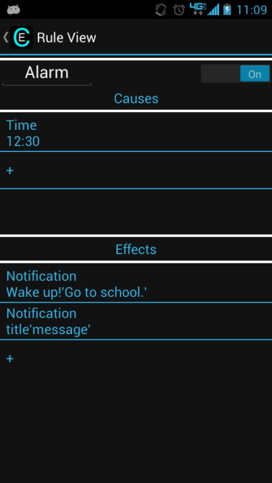

Rule with full Notification effect

**Test 29: Adding Play Sound effect.**

Verifies user story: 91

Test by having the user try to add the effect of sound.

Process

After getting past Test 3, tap the “+” below the effects list to create a new effect. Tap “Play Sound”. A “Select a File to Play” dialog should appear and tell you to pick a way to choose your sound. Select the option of your choice, and choose a sound to play. Verify that the new effect appears at the bottom of the effect list, and that the rule effect is triggered by activating the rule (making the causes true, whatever they may be).

Results

“Play Sound” is an effect listed (yes/no):______

“Select a File to Play” dialog appears (yes/no):______

Able to create new effect with correct sound file displayed (yes/no):______

Correct sound is played (yes/no):______

Comments:

________________________________________________________________________

________________________________________________________________________

[Passed/Failed]

____________

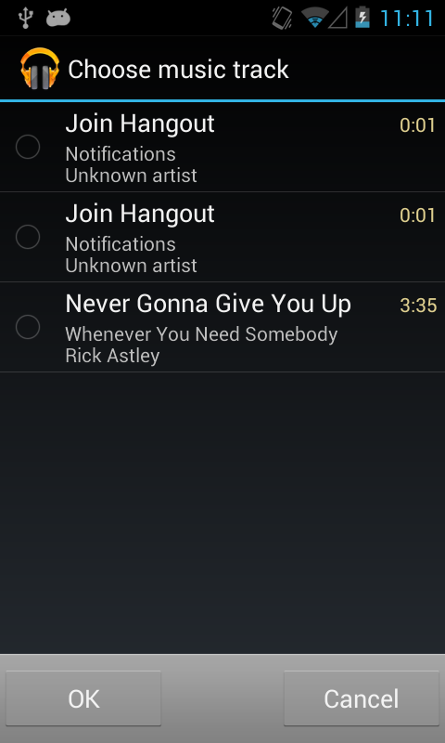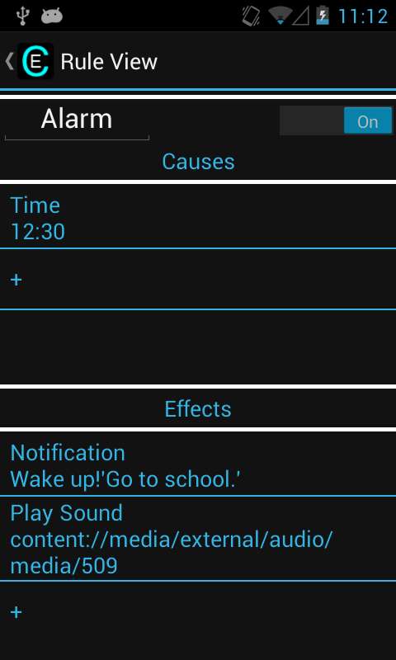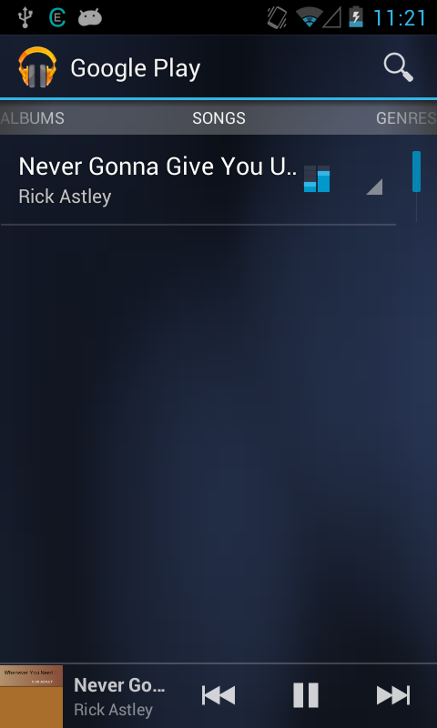

Adding new play sound Rule with new play sound Play sound effect playing

**Test 30: Adding Ring Mode effect (Normal).**

Verifies user story: 92

Test by having the user try to add the effect of ring mode.

Process

After getting past Test 3, tap the “+” below the effects list to create a new effect. Tap “Ring Mode”. A “Ring Mode” dialog should appear with 3 options. Tap on “Normal”. Verify that the new effect appears at the bottom of the effect list and that the rule effect is triggered by activating the rule (making the causes true, whatever they may be).

Results

“Ring Mode” is an effect listed (yes/no):______

“Ring Mode” dialog appears with 3 options (yes/no):______

Able to create new effect with “Normal” for ring mode (yes/no):______

Ring mode effect added to list (yes/no):______

Effect is displayed correctly (yes/no):______

Comments:

________________________________________________________________________

________________________________________________________________________

[Passed/Failed]

____________

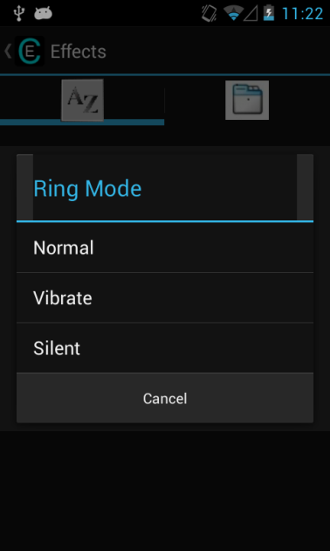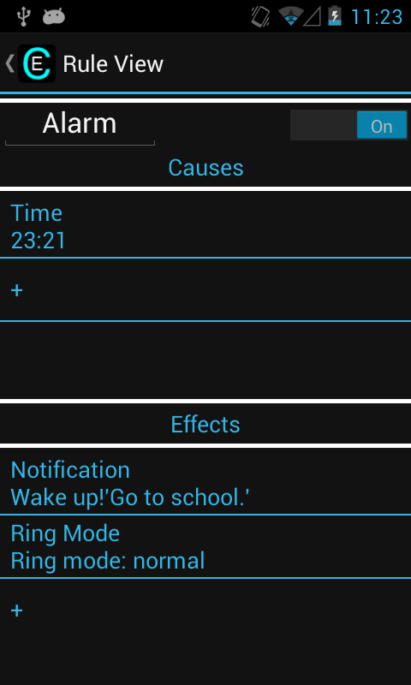

Adding Ring Mode effect Rule with new Ring Mode

**Test 31: Adding Ring Mode effect (Vibrate).**

Verifies user story: 92

Test by having the user try to add the effect of ring mode.

Process

Starting with dialog box from Test 30, tap on “Vibrate”. Verify that the new effect appears at the bottom of the effect list, and that the rule effect is triggered by activating the rule (making the causes true, whatever they may be).

Results

Able to create new effect with “Vibrate” for ring mode (yes/no):______

Ring mode effect added to list (yes/no):______

Effect is displayed correctly (yes/no):______

Comments:

________________________________________________________________________

________________________________________________________________________

[Passed/Failed]

____________

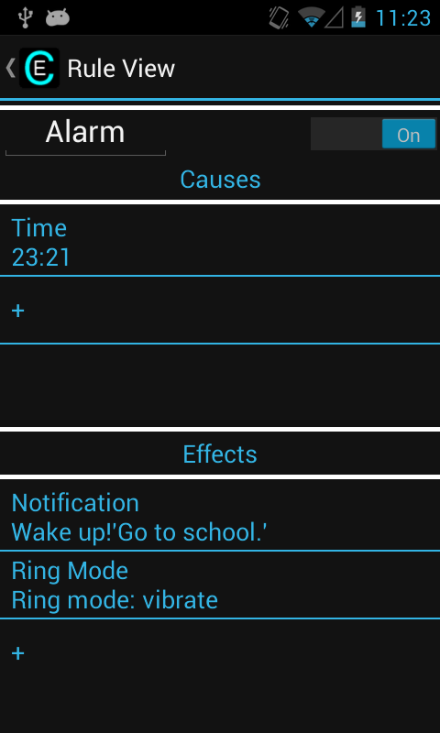

Rule with new Ring mode effect (vibrate)

**Test 32: Adding Ring Mode effect (Silent).**

Verifies user story: 92

Test by having the user try to add the effect of ring mode.

Process

Starting with dialog box from Test 30, tap on “Silent”. Verify that the new effect appears at the bottom of the effect list, and that the rule effect is triggered by activating the rule (making the causes true, whatever they may be).

Results

Able to create new effect with “Silent” for ring mode (yes/no):______

Ring mode effect added to list (yes/no):______

Effect is displayed correctly (yes/no):______

Comments:

________________________________________________________________________

________________________________________________________________________

[Passed/Failed]

____________

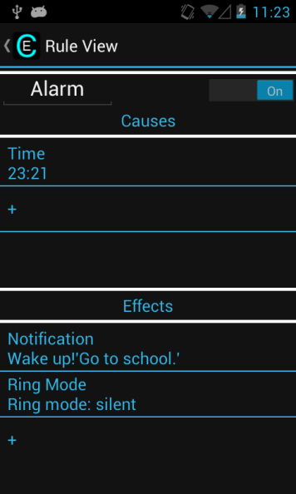

Rule with new Ring Mode effect (silent)

**Test 33: Adding Toast effect (blank).**

Verifies user story: 63

Test by having the user try to add the effect of Toast.

Process

After getting past Test 3, tap the “+” below the effects list to create a new effect. Tap “Toast”. A “New Toast” dialog should appear with an empty Message text input. Leave the message blank and tap Submit. Verify that the new effect appears at the bottom of the effect list, and that the rule effect is triggered by activating the rule (making the causes true, whatever they may be).

Results

“Toast” is an effect listed (yes/no):______

Able to create new effect with blank message (yes/no):______

Toast effect added to list (yes/no):______

Effect is displayed correctly (yes/no):______

Comments:

________________________________________________________________________

________________________________________________________________________

[Passed/Failed]

____________

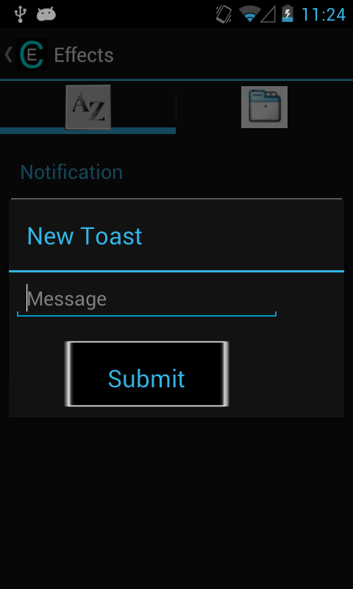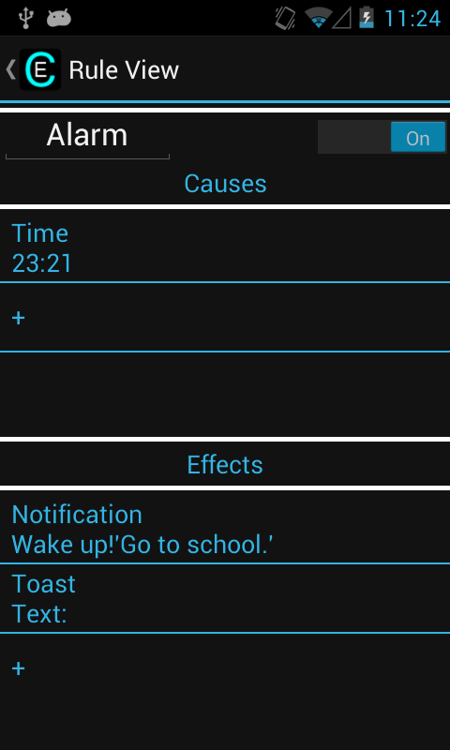

Adding new Toast effect Rule with new Toast effect

**Test 34: Adding Toast effect.**

Verifies user story: 63

Test by having the user try to add the effect of Toast.

Process

From the new Toast dialog, enter a message and tap Submit. Verify that the new effect appears at the bottom of the effect list, and that the rule effect is triggered by activating the rule (making the causes true, whatever they may be).

Results

Able to create new effect with correct message (yes/no):______

Toast effect added to list (yes/no):______

Effect is displayed correctly (yes/no):______

Comments:

________________________________________________________________________

________________________________________________________________________

[Passed/Failed]

____________

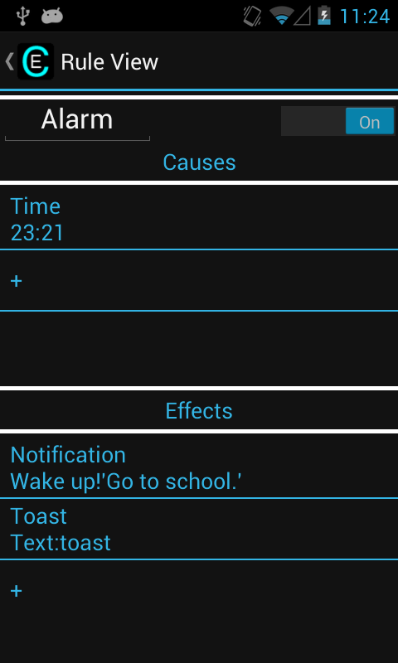

Rule with new Toast effect (full)

**Test 35: Adding Vibrate effect.**

Verifies user story: 64,95

Test by having the user try to add the effect of Vibrate.

Process

After getting past Test 3, tap the “+” below the effects list to create a new effect. Tap “Vibrate”. Verify that the new effect appears at the bottom of the effect list, and that the rule effect is triggered by activating the rule (making the causes true, whatever they may be).

Results

“Vibrate” is an effect listed (yes/no):______

Vibrate is added to effect list (yes/no):______

Effect is displayed correctly (yes/no):______

Comments:

________________________________________________________________________

________________________________________________________________________

[Passed/Failed]

____________

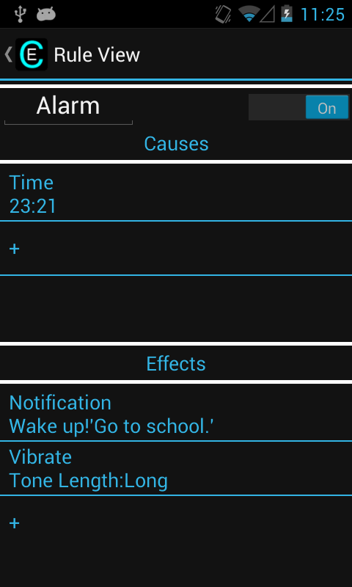

Rule with Vibrate effect

**Test 36: Editing Arrive cause.**

Verifies user story: 86

Test by having the user try to edit the Arrive cause.

Process

After adding an arrive cause (see earlier tests), tap the cause. Verify that the map appears and allows you to set a new location. Input a new location (following the Test 7or adding an arrive cause). The updated information should now appear in the cause list. Finally, verify that the rule now activates when this new cause is true.

Results

Map appears when you tap on arrival cause (yes/no):______

Able to make the new cause (yes/no):______

Updated cause is displayed correctly (yes/no):______

New cause triggers rule effects (yes/no):______

Old cause does not trigger rule effects (yes/no):______

Comments:

________________________________________________________________________

________________________________________________________________________

[Passed/Failed]

____________

**Test 37: Editing Depart cause.**

Verifies user story: 86

Test by having the user try to edit the Depart cause.

Process

After adding a depart cause (see earlier tests), tap the cause. Verify that the map appears and allows you to set a new location. Input a new location (following the Test 7or adding an arrive cause). The updated information should now appear in the cause list. Finally, verify that the rule now activates when this new cause is true.

Results

Map appears when you tap on depart cause (yes/no):______

Able to make the new cause (yes/no):______

Updated cause is displayed correctly (yes/no):______

New cause triggers rule effects (yes/no):______

Old cause does not trigger rule effects (yes/no):______

Comments:

________________________________________________________________________

________________________________________________________________________

[Passed/Failed]

____________

**Test 38: Editing Phone Call cause.**

Verifies user story: 86

Test by having the user try to edit the Phone Call cause.

Process

After adding a phone call cause (see earlier tests), tap the cause. Verify that the contact list appears and allows you to set a new contact. Input a new contact (following the Test 7or adding a phone call cause). The updated information should now appear in the cause list. Finally, verify that the rule now activates when this new cause is true.

Results

Contact list appears when you tap on phone call cause (yes/no):______

Able to make the new cause (yes/no):______

Updated cause is displayed correctly (yes/no):______

Old cause does not trigger rule effects (yes/no):______

New cause triggers rule effects (yes/no):______

Comments:

________________________________________________________________________

________________________________________________________________________

[Passed/Failed]

____________

**Test 39: Editing Text Message cause.**

Verifies user story: 86

Test by having the user try to edit the Text Message cause.

Process

After adding a text message cause (see earlier tests), tap the cause. Verify that the contact list appears and allows you to set a new contact. Input a new contact (following the Test 7or adding a text message cause). The updated information should now appear in the cause list. Finally, verify that the rule now activates when this new cause is true.

Results

Contact list appears when you tap on text message cause (yes/no):______

Able to make the new cause (yes/no):______

Updated cause is displayed correctly (yes/no):______

New cause triggers rule effects (yes/no):______

Old cause does not trigger rule effects (yes/no):______

Comments:

________________________________________________________________________

________________________________________________________________________

[Passed/Failed]

____________

**Test 40: Editing Time cause.**

Verifies user story: 86

Test by having the user try to edit the Time cause.

Process

After adding a time cause (see earlier tests), tap the cause. Verify that the same dialog appears asking for a time. Input a new time and tap OK. The updated information should now appear in the cause list. Finally, verify that the rule now activates when this new cause is true.

Results

Time dialog appears when you tap on time cause (yes/no):______

Updated cause is displayed correctly (yes/no):______

New cause triggers rule effects (yes/no):______

Old cause does not trigger rule effects (yes/no):______

Comments:

________________________________________________________________________

________________________________________________________________________

[Passed/Failed]

____________

**Test 41: Editing Wi-Fi SSID cause.**

Verifies user story: 86

Test by having the user try to edit the Wi-Fi SSID cause.

Process

After adding a Wi-Fi ssid cause (see earlier tests), tap the cause. Verify that the same dialog appears asking for a Wi-Fi ssid. Input a new ssid and tap Submit. The updated information should now appear in the cause list. Finally, verify that the rule now activates when this new cause is true.

Results

Wi-Fi SSID dialog appears when you tap on Wi-Fi SSID cause (yes/no):______

Updated cause is displayed correctly (yes/no):______

New cause triggers rule effects (yes/no):______

Old cause does not trigger rule effects (yes/no):______

Comments:

________________________________________________________________________

________________________________________________________________________

[Passed/Failed]

____________

**Test 42: Editing Wi-Fi Status cause.**

Verifies user story: 86

Test by having the user try to edit the Wi-Fi Status cause.

Process

After adding a Wi-Fi status cause (see earlier tests), tap the cause. Verify that the same dialog appears with the slider. Switch the slider to the opposite of what is set, and tap Submit. The updated information should now appear in the cause list. Finally, verify that the rule now activates when this new cause is true.

Results

Wi-Fi Status dialog appears when you tap on Wi-Fi Status cause (yes/no):______

Updated cause is displayed correctly (yes/no):______

New cause triggers rule effects (yes/no):______

Old cause does not trigger rule effects (yes/no):______

Comments:

________________________________________________________________________

________________________________________________________________________

[Passed/Failed]

____________

**Test 43: Editing Notification effect.**

Verifies user story: 87

Test by having the user try to edit the Notification effect.

Process

After adding a notification effect (see earlier tests), tap the effect. Verify that the same dialog appears asking for text for the notification. Input new text and tap Submit. The updated information should now appear in the effect list. Finally, verify that when the rule is activated the new effect appears.

Results

Notification dialog appears when you tap on Notification effect (yes/no):______

Updated effect is displayed correctly (yes/no):______

New effect is displayed (yes/no):______

Old effect is not displayed (yes/no):______

Comments:

________________________________________________________________________

________________________________________________________________________

[Passed/Failed]

____________

**Test 44: Editing Sound effect.**

Verifies user story: 87

Test by having the user try to edit the Sound effect.

Process

After adding a sound effect (see earlier tests), tap the effect. Verify that the same dialog appears asking for which program to use to select the new sound. Use any input, and select a new sound. The updated information should now appear in the effect list. Finally, verify that when the rule is activated the new effect appears.

Results

Sound dialog appears when you tap on Sound effect (yes/no):______

Updated effect is displayed correctly (yes/no):______

New effect is played (yes/no):______

Old effect is not played (yes/no):______

Comments:

________________________________________________________________________

________________________________________________________________________

[Passed/Failed]

____________

**Test 45: Editing Ring Mode effect.**

Verifies user story: 87

Test by having the user try to edit the Ring Mode effect.

Process

After adding a ring mode effect (see earlier tests), tap the effect. Verify that the same dialog appears asking for which ring mode to use. Select a different ring mode. The updated information should now appear in the effect list. Finally, verify that when the rule is activated the new effect appears.

Results

Ring Mode dialog appears when you tap on Ring Mode effect (yes/no):______

Updated effect is displayed correctly (yes/no):______

New effect is used (yes/no):______

Old effect is not used (yes/no):______

Comments:

________________________________________________________________________

________________________________________________________________________

[Passed/Failed]

____________

**Test 46: Editing Toast effect.**

Verifies user story: 87

Test by having the user try to edit the Toast effect.

Process

After adding a toast effect (see earlier tests), tap the effect. Verify that the same dialog appears asking for text for the toast. Input new text, and tap Submit. The updated information should now appear in the effect list. Finally, verify that when the rule is activated the new effect appears.

Results

Toast dialog appears when you tap on Toast effect (yes/no):______

Updated effect is displayed correctly (yes/no):______

New effect is displayed (yes/no):______

Old effect is not displayed (yes/no):______

Comments:

________________________________________________________________________

________________________________________________________________________

[Passed/Failed]

____________

**Test 47: Editing Vibrate effect.**

Verifies user story: 87

Test by having the user try to edit the Notification effect.

Process

After adding a vibrate effect (see earlier tests), tap the effect. Verify that no dialog appears.

Results

No dialog appears (yes/no):______

Comments:

________________________________________________________________________

________________________________________________________________________

[Passed/Failed]

____________

**Test 48: Able to delete causes.**

Verifies user story: 88

Test by having user delete a cause.

Process

After adding a cause, long tap (tap and hold) on a cause to verify that the delete dialog appears. Test the "no" or "cancel" option on this dialog (nothing should happen). Then test the "Delete" option, which should delete the cause from the list.

Results

Delete dialog appears for causes (yes/no):______

Nothing happens if you tap no (yes/no):______

Deleted cause if you tap yes (for cause) (yes/no):______

Rule activates correctly after deletion of cause (yes/no):______

Comments:

________________________________________________________________________

________________________________________________________________________

[Passed/Failed]

____________

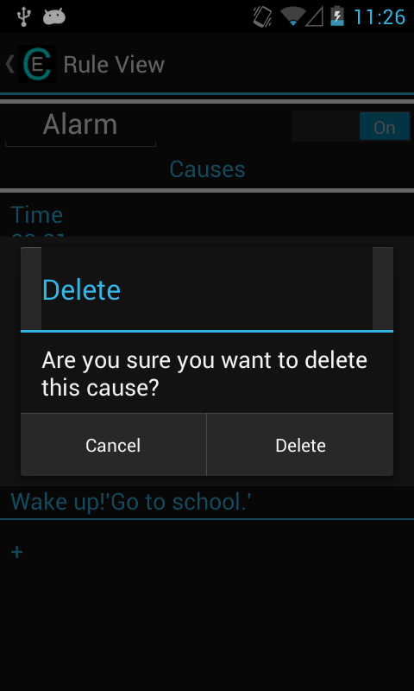

Delete cause dialog

**Test 49: Able to delete effects.**

Verifies user story: 89

Test by having user delete an effect.

Process

After adding an effect, long tap on an effect to verify that delete dialog appears. Test the "no" or "cancel" option on this dialog (nothing should happen). Then test the "Delete" option, which should delete the effect from the list.

Results

Delete dialog appears for effects (yes/no):______

Nothing happens if you tap no (yes/no):______

Deleted effect if you tap yes (for effect) (yes/no):______

Rule activates correctly after deletion of effect (yes/no):______

Comments:

________________________________________________________________________

________________________________________________________________________

[Passed/Failed]

____________

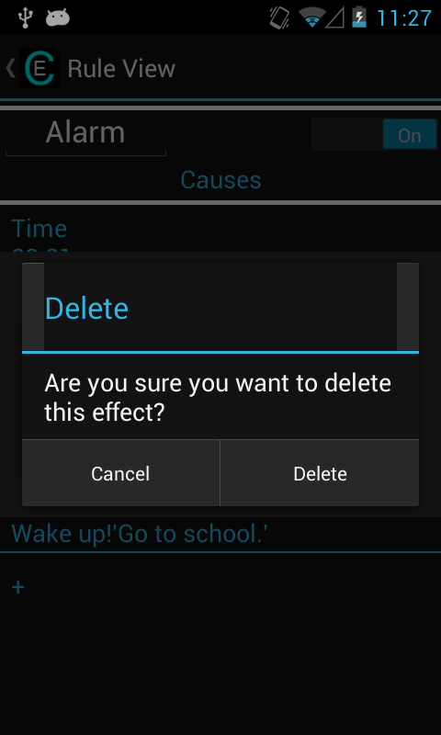

Delete effect dialog

**Test 50: Able to delete rules.**

Verifies user story: 25

Test by having user delete a rule.

Process

While looking at the rule list, long tap on a rule to verify that delete dialog appears. Test the "no" or "cancel" option on this dialog (nothing should happen). Then test the "Delete" option, which should delete the rule from the list.

Results

Delete dialog appears for rules (yes/no):______

Nothing happens if you tap no (yes/no):______

Deleted rule if you tap yes (yes/no):______

Rule no longer appears and does not activate (yes/no):______

Comments:

________________________________________________________________________

________________________________________________________________________

[Passed/Failed]

____________

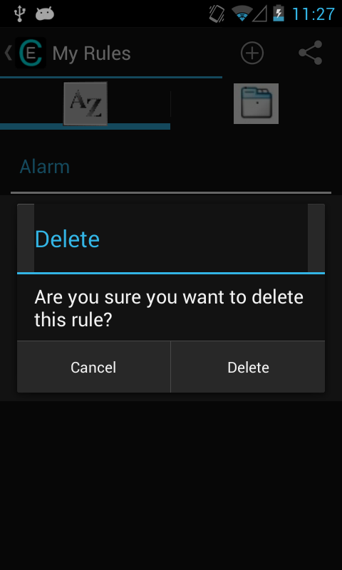

Delete rule dialog

**Test 51: Up button functionality works.**

Verifies user story: 79,104,105

Test by using integrated up button at top of screen while inside of app.

Process

While inside of an activity (any screen other than main menu), try using the integrated up button to return to the previous major screen. This should eventually lead back to the main screen without going back through your screen history (e.g. edit rule -> rule list, rule list -> main menu, new rule -> rule list).

Note: the back button on phones is more of an undo, so using that is not applicable for this test, but can still be used.

Results

Up button is visible on all screens but Main Menu (yes/no):______

Up button works as intended (listed in process) (yes/no):______

[Passed/Failed]

____________

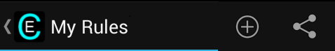

**Test 52: Able to change name of rule.**

Verifies user story: 25

Test by changing the name of a rule and verifying it has updated.

Process

While in the editing page of a rule, tap on the rule name, and edit it (does not matter what you name it). Then use the back button (from Test 51) to go back to the rule list. The rule name should be updated in this list. Tap on the rule again to make sure the correct name appears in the edit rule page again.

Results

Able to edit name of rule (able to change text) (yes/no):______

New name appears in rule list (yes/no):______

New name appears again in edit rule page (yes/no):______

[Passed/Failed]

____________

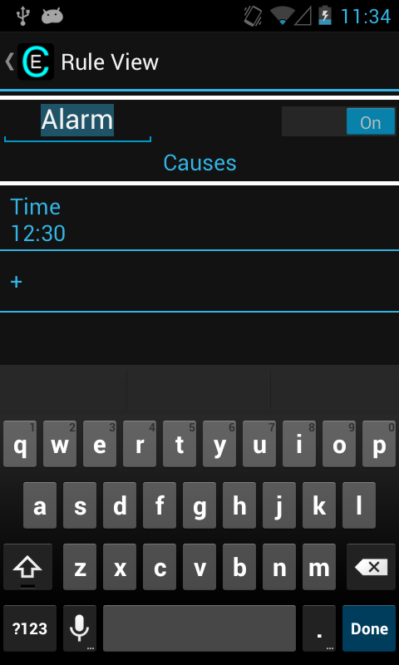

Editing Rule name

**Test 53: Able to change rule active.**

Verifies user story: 70

Test by changing the rule active icon in edit rule page.

Process

While in edit rule page, change the slider at the top of the rule (either slide or tap) to off (default is on usually, change to on if already off). Verify that the rule works now. Then, repeat after changing it back to the original state.

Results

Slider is visible (yes/no):______

Able to change slider using slide (yes/no):______

Able to change slider using tap (yes/no):______

Rule does not activate while in off position (yes/no):______

Rule does activate while in on position (yes/no):______

[Passed/Failed]

____________

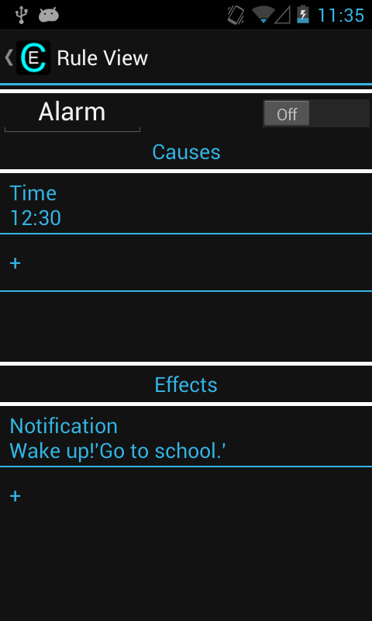

Rule with active set to off

**Test 54: Able to add rule.**

Verifies user story: 3

Test by adding a new rule.

Process

From main menu, tap “New Rule” to start making a new rule. A blank rule should show up with “Untitled” as the name. Add a cause and/or an effect. This makes the rule permanent. Use the up button to go back to the rules list. Your new rule should appear there.

Results

Blank rule appears (yes/no):______

New rule after instantiated appears (yes/no):______

[Passed/Failed]

____________

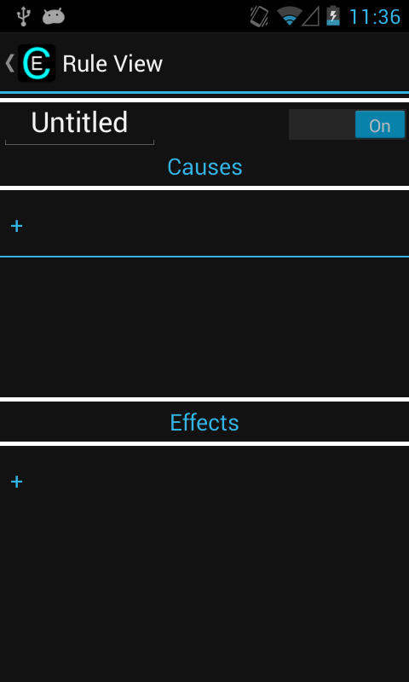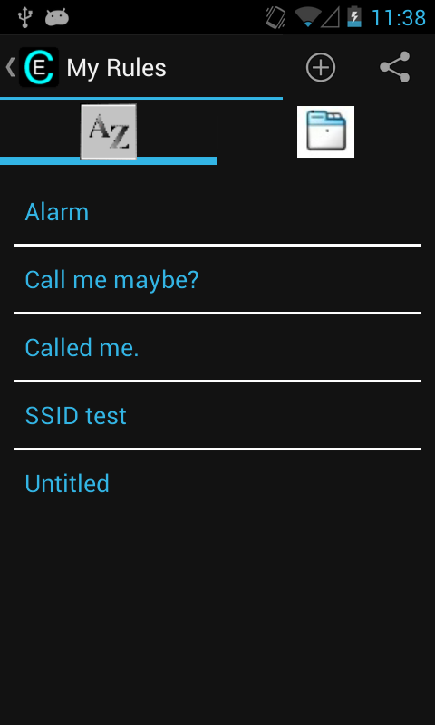

Adding new rule New rule appears in list

**Test 55: Able to add rule (blank).**

Verifies user story: 3

Test by adding a new rule.

Process

From main menu, tap “New Rule” to start making a new rule. A blank rule should show up with “Untitled” as the name. Do not add any causes or effects. Use the up button to go back to the rules list. The new rule should not appear in the list. A Toast message should notify you that the rule was not added.

Results

New rule does not appear (yes/no):______

[Passed/Failed]

____________

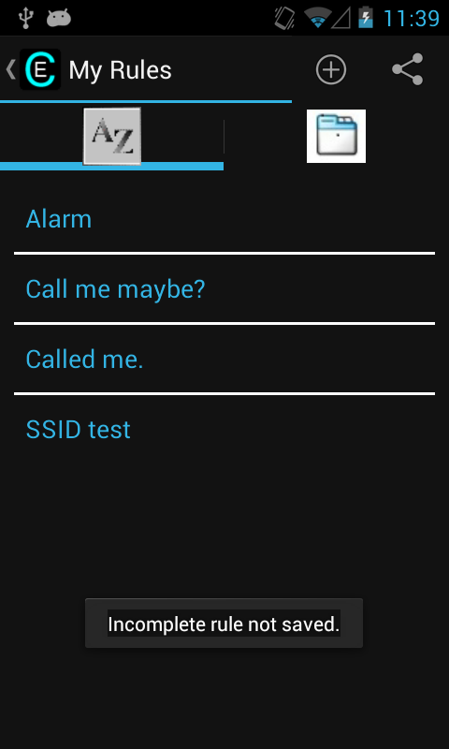

Notification warning of blank rule

**Test 56: Test the sharing functions (NFC).**

Verifies user story: 97,98

Test by trying to share a rule through NFC.

Process

From the Main Menu, tap the share button. Choose a rule that you wish to share. When the phone says it is "Ready to send" your rule over NFC, pickup the receiving phone (which has the application installed). Press the backs of the two phones together. As they touch, the sending phone should vibrate and shrink the UI to a smaller size. When this occurs, tap and hold the screen to send the rule to the other device. As long as the application is installed on the other phone, the phone is on, and the application has been opened at least once, the other phone will receive the rule from any screen. This should occur even when a different application is open on the receiving phone. Verify that the rule was transferred by viewing the rule list on the receiving phone, and test that the rule still works properly.

Results

Able to share rule via NFC (yes/no): ______

Shared rule appears in rule list (yes/no):______

Rule works as originally intended (yes/no):______

[Passed/Failed]

____________

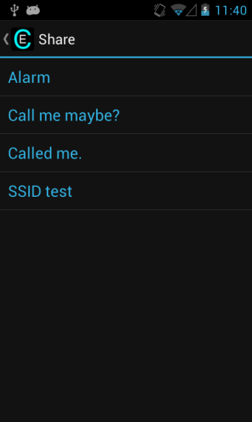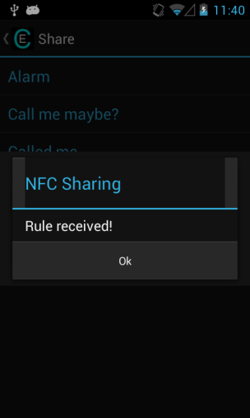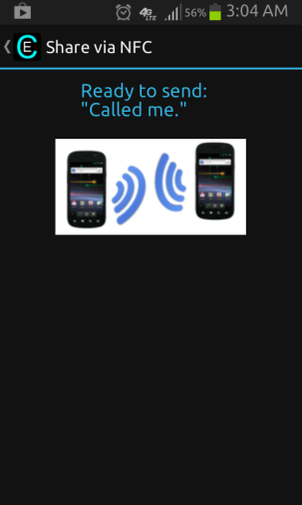

Rule list for sharing When rule is received Ready to send rule

**Test 57: Make sure the Boolean algebra is added correctly.**

Verifies user story: 74,100

Test by adding a 2nd cause on any rule.

Process

Go to any rule that has at least 1 cause, and add any cause. An OR should be added between the causes. Then, delete a cause and the OR/AND should be removed from the cause list.

Results

OR is added between causes (yes/no):______

OR/AND is deleted when cause is deleted (yes/no):______

[Passed/Failed]

____________

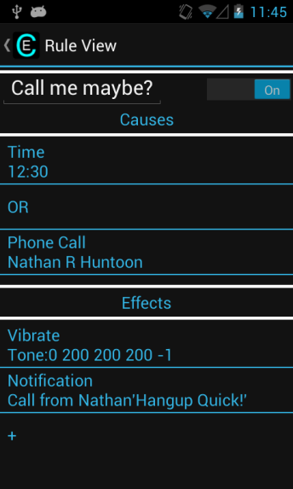

Rule with multiple causes

**Test 58: Make sure the Boolean algebra works correctly (AND).**

Verifies user story: 74,100

Test by making a rule with ANDs in the cause list, and test that it works properly.

Process

Set up one of the rules with multiple causes. Tap on an OR box to change it to an AND. Activate the rule, and test that the logic works properly (see below).

Note: with the AND rule, make sure both causes can be active at the same time (e.g. time and location, time and Wi-Fi are good examples).

Results

Able to change OR to AND between causes (yes/no):______

Rule is activated when both causes true(yes/no): ______

Rule is not activated when first cause true and second cause false (yes/no):______

Rule is not activated when second cause true and first cause false (yes/no):______

Rule is not activated when both causes are false (yes/no):______

[Passed/Failed]

____________

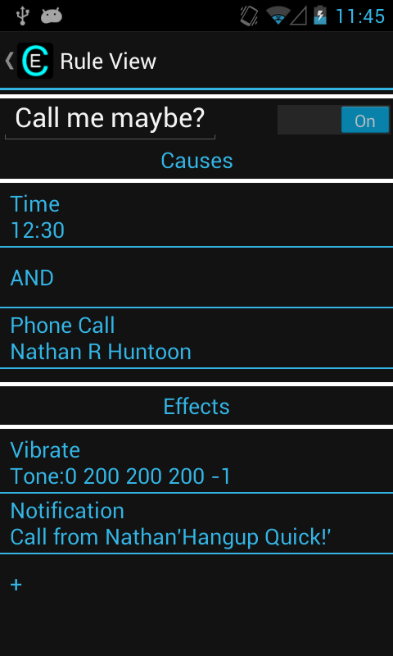

Rule with AND between causes

**Test 59: Make sure the Boolean algebra works correctly (OR).**

Verifies user story: 74,100

Test by making a rule with ORs in the cause list, and test that it works properly.

Process

Set up one of the rules with multiple causes. Tap on an AND box to change it to an OR, if necessary. Activate the rule, and test that the logic works properly (see below).

Note: with the OR rule, either cause can trigger a rule

Results

Able to change AND to OR between causes (yes/no):______

Rule is activated when both causes true(yes/no): ______

Rule is activated when first cause true and second cause false (yes/no):______

Rule is activated when second cause true and first cause false (yes/no):______

Rule is not activated when both causes are false (yes/no):______

[Passed/Failed]

____________

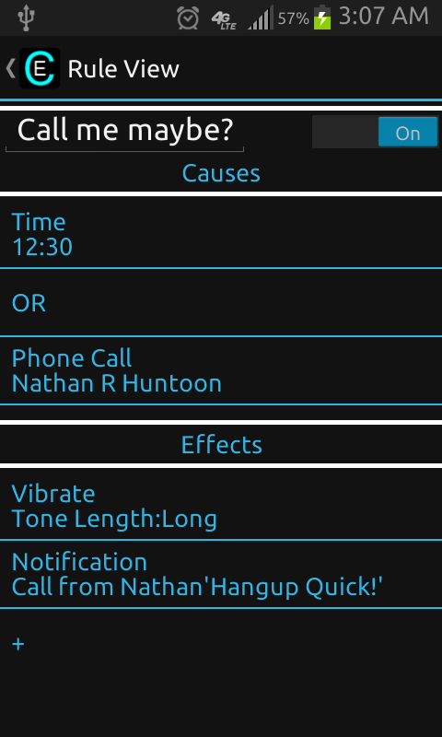

Rule with OR between causes

**Test 60: Make sure you cannot add duplicate causes.**

Verifies user story: 84

Test by trying to add a duplicate cause to a rule.

Process

Go into the edit page of any rule and try to add a duplicate of any of the causes (same cause, same arguments). The new cause should not be added to the rule.

Results

New duplicate cause is not added to rule (yes/no):______

Toast is shown notifying the user that it has found a duplicate cause (yes/no):______

[Passed/Failed]

____________

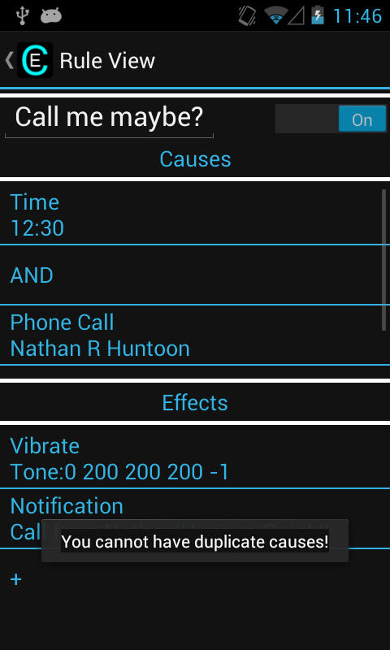

Warning when adding duplicate causes

**Test 61: Make sure you cannot add duplicate effects.**

Verifies user story: 84

Test by trying to add a duplicate effect to a rule.

Process

Go into the edit page of any rule and try to add a duplicate of any of the effects (same effect, same arguments). The new effect should not be added to the rule.

Results

New duplicate effect is not added to rule (yes/no):______

Toast is shown notifying the user that it has found a duplicate effect (yes/no):______

[Passed/Failed]

____________

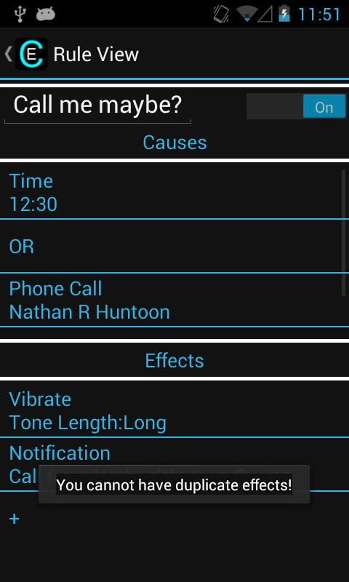

Warning when adding duplicate effects

**Test 62: Bring up menu in My Rules (rule list).**

Verifies user story: 25

Test by pressing the Menu key while inside of My Rules. The Menu can either be a hardware button on the bottom of the phone or 3 vertical dots on the top action bar.

Process

Go into the My Rules page and press Menu. The Menu should pop up with Settings/Preferences.

Results

Menu shows up with only Settings appearing (yes/no):______

[Passed/Failed]

____________

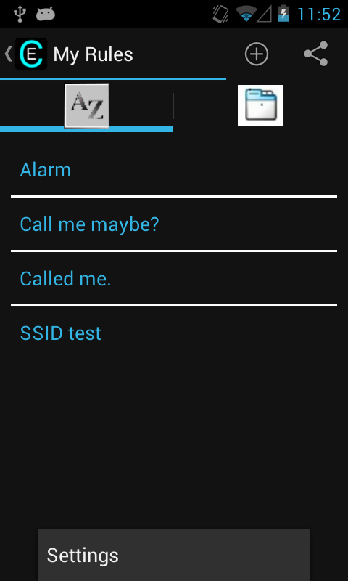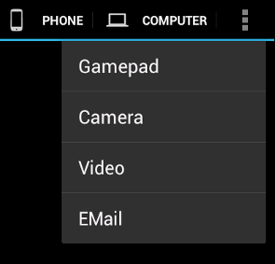

Menu in My Rules Menu Button in the top right

**Test 63: Bring up menu in Edit Rule.**

Verifies user story: 25

Test by pressing the Menu key while inside of Edit Rule.

Process

Go into the Edit Rule page and press Menu. The Menu should pop up with Settings/Preferences and Help.

Results

Menu shows up with Settings and Help appearing (yes/no):______

[Passed/Failed]

____________

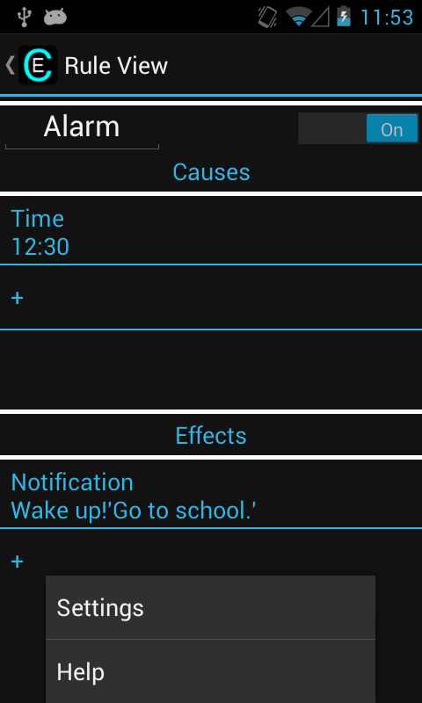

Menu in Edit Rule

**Test 64: Bring up menu in Help.**

Verifies user story: 23,26,76, 123

Test by pressing the Menu key while inside of Help page.

Process

Go into the Help page and press Menu. The Menu should pop up with Preferences.

Results

Menu shows up with only Settings appearing (yes/no):______

[Passed/Failed]

____________

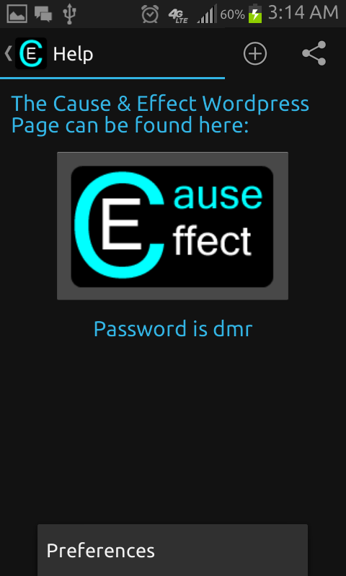

Menu in Help

**Test 65: Bring up menu in Settings.**

Verifies user story: 27

Test by pressing the Menu key while inside of Settings page.

Process

Go into the Settings page and press Menu. The Menu should pop up with Help.

Results

Menu shows up with only Help appearing (yes/no):______

[Passed/Failed]

____________

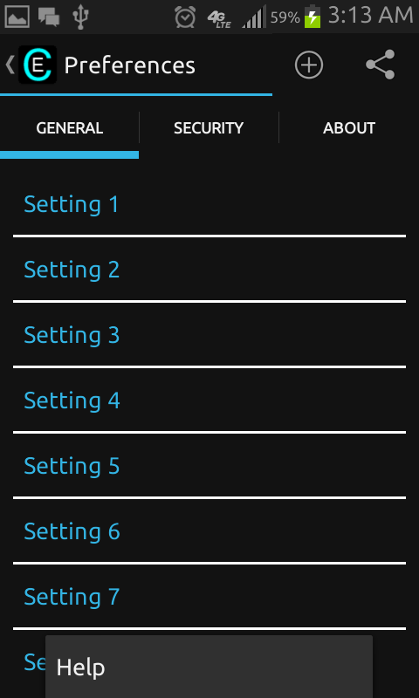

Menu in Settings

**Test 66: Test Settings tabs.**

Verifies user story: 9,10,11,12,13,14

Test by pressing the tabs in the Settings page to make sure all the tabs work.

Process

Go into the Settings page and press the General tab, Accounts tab, Security tab, and About tab and make sure they work.

Results

General tab works (yes/no):______

Accounts tab works (yes/no):______

Security tab works (yes/no):______

About tab works (yes/no):______

[Passed/Failed]

____________

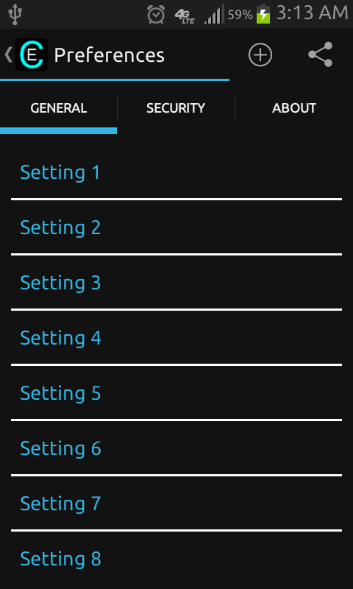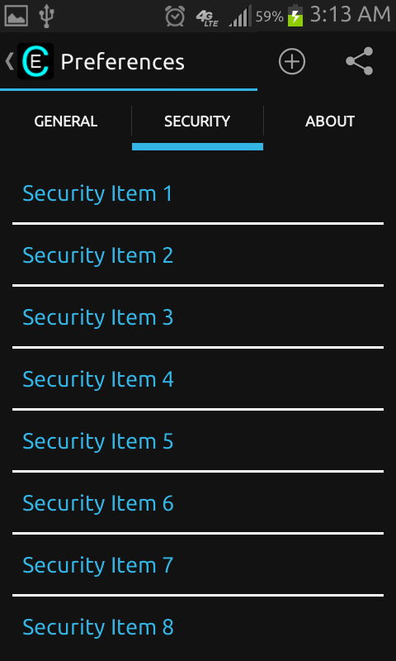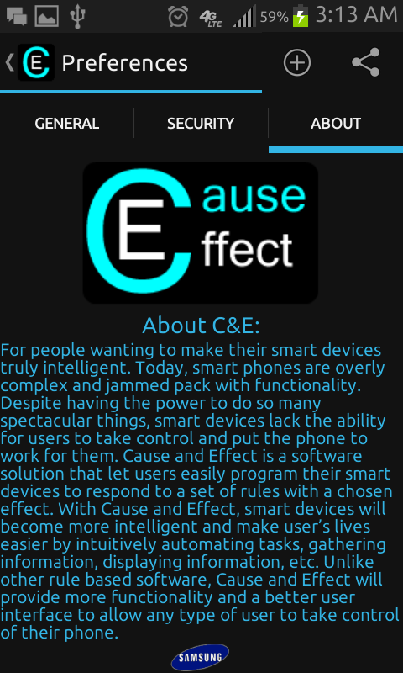

Setting General Tab Settings Security Tab Settings About Tab

**Test 67: Test application service.**

Verifies user story: 83,90,103

Test by returning to the home screen and activating the rule.

Process

Make sure there is a relatively simple rule to activate and then exit out of the app by constantly pressing the android back button (or simply press the Home button). Then activate the rule to make sure it works.

Results

Rule activates while app is closed (yes/no):______

[Passed/Failed]

____________